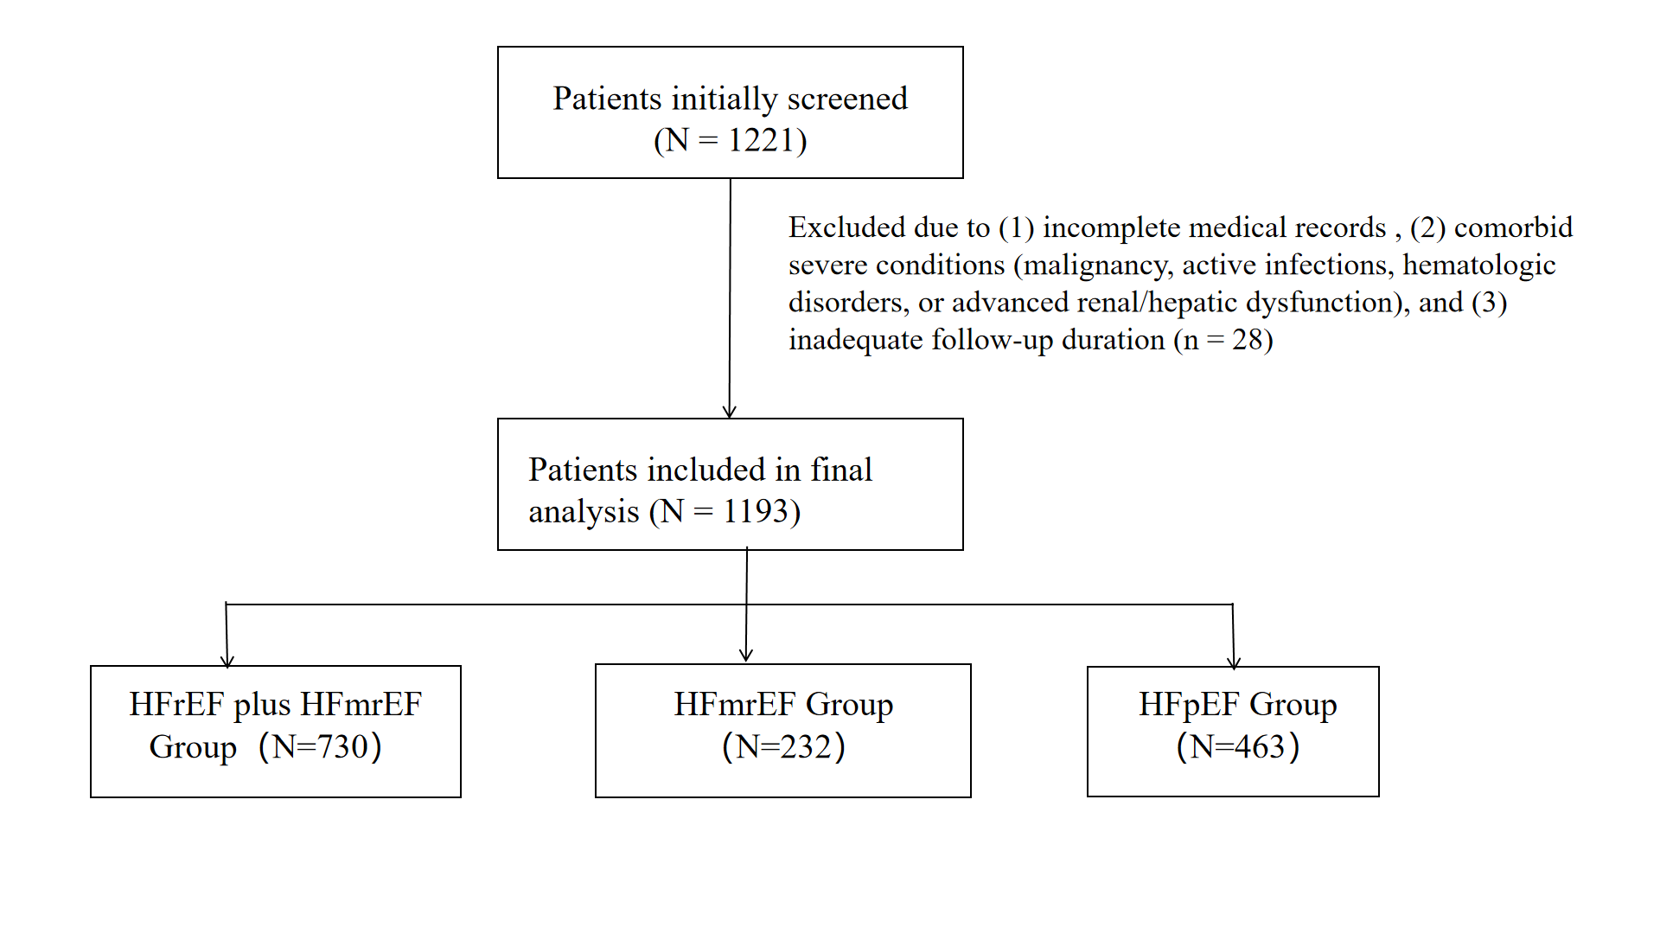
Supplementary Fig. 1. Patient eligibility flowchart

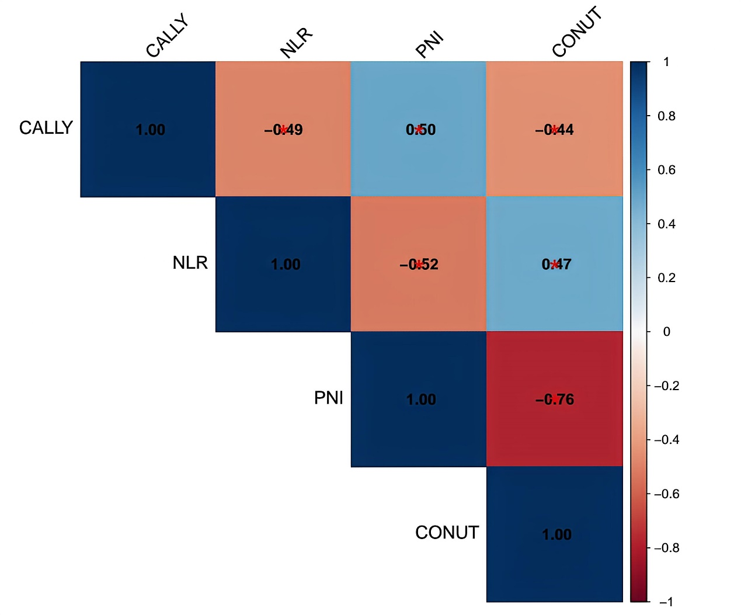
Supplementary Fig. 2 The correlation between the CALLY level, PNI level, CONUT score and NLR level.
Supplementary Table 1 Survival outcomes stratified by CALLY groups
Population | CALLY Group | n | Death events, n (%) | Censored, n (%) | Loss to follow-up, n (%)
Total heart failure cohort | Low (<0.62) | 598 | 383 (64.0) | 215 (36.0) | 215 (36.0)
 | High (≥0.62) | 595 | 179 (30.1) | 416 (69.9) | 416 (69.9)
 | Overall | 1,193 | 562 (47.1) | 631 (52.9) | 631 (52.9)
HFrEF plus HFmrEF
 | Low (<0.62) | 369 | 248 (67.2) | 121 (32.8) | 121 (32.8)
 | High (≥0.62) | 361 | 114 (31.6) | 247 (68.4) | 247 (68.4)
 | Overall | 730 | 362 (49.6) | 368 (50.4) | 368 (50.4)
HFpEF
 | Low (<0.62) | 229 | 135 (59.0) | 94 (41.0) | 94 (41.0)
 | High (≥0.62) | 234 | 65 (27.8) | 169 (72.2) | 169 (72.2)
 | Overall | 463 | 200 (43.2) | 263 (56.8) | 263 (56.8)
CALLY groups were defined based on the optimal cutoff (0.62) derived from restricted cubic spline analysis: low CALLY (<0.62) and high CALLY (≥0.62). Loss to follow‑up was defined as patients who were alive at the end of the study period without experiencing the outcome of interest or who were lost before study completion. Event rates and censored rates are presented as n (% of the group total).

Supplementary Table 2 Proportional Hazards Assumption Test Results.
Variable | Chisq | df | p_value | PH_Status
Age | 0.147 | 1 | 0.7015 | Satisfied
Gender | 0.089 | 1 | 0.7656 | Satisfied
BMI | 0.104 | 1 | 0.7467 | Satisfied
NYHA | 0.156 | 1 | 0.6931 | Satisfied
`Pulmonary arterial systolic pressure` | 0.415 | 1 | 0.5194 | Satisfied
lgBNP | 12.928 | 1 | 0.0003 | Violated
WBC | 0.526 | 1 | 0.4681 | Satisfied
Hb | 0.12 | 1 | 0.729 | Satisfied
Sodium | 7.091 | 1 | 0.0077 | Violated
Chlorine | 0.02 | 1 | 0.8865 | Satisfied
ALT | 0.025 | 1 | 0.8737 | Satisfied
AST | 1.388 | 1 | 0.2388 | Satisfied
Urea | 0.087 | 1 | 0.7679 | Satisfied
GFR | 7.283 | 1 | 0.0070 | Violated
FBG | 0 | 1 | 0.9892 | Satisfied
UA | 1.649 | 1 | 0.1991 | Satisfied
TC | 0.097 | 1 | 0.756 | Satisfied
Group | 0.05 | 1 | 0.8223 | Satisfied
GLOBAL | 44.705 | 18 | 0.0005 | Violated
The proportional hazards assumption was tested using Schoenfeld residuals. A p value > 0.05 indicates that the proportional hazards assumption is not violated. Global test represents the overall test for all covariates simultaneously.

